Program should start with user input to collect school name and we need to print menu options with school name as shown below.

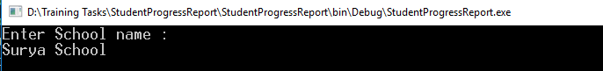

Once school name is collected. Show this menu options to user to perform allowed options

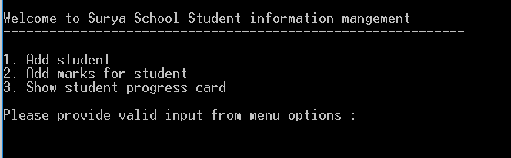

When user selects option 1, need to collect basic details of student like roll number and name as shown below.

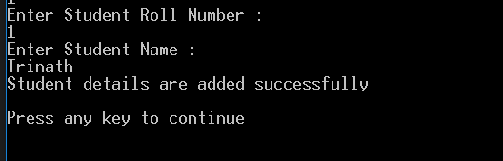

When user selects option 2, need to collect student marks for already added students only. See below screen for reference.

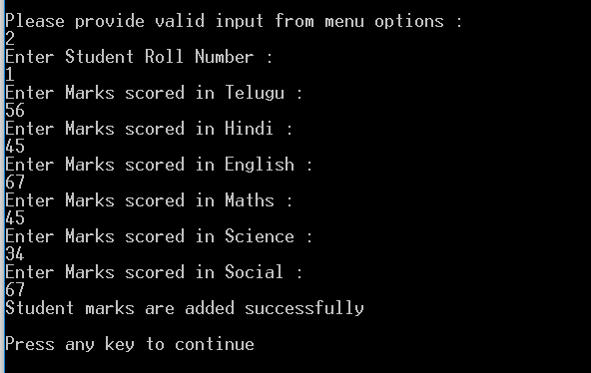

When user selected option 3, we need to show student marks based on given roll number as input

